**VECTR v5.2.4 Feature Breakdown**

Table of Contents

DB Selection Clarity 2

Renaming downloadable reports 3

Tagging column to downloadable reports 4

Help Button Improvements 4

Database CSV Dump 6

# DB Selection Clarity

What is it?

Allows the user to select their session database or create a new one.

How does it work?

You can access the DB Selection screen in the top right corner:

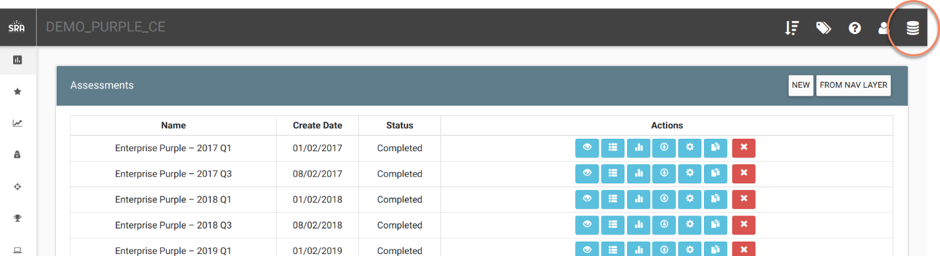

This will take you to the DB Selection Screen. There is a “+” at the bottom that will allow you to enter in a new DB to start from scratch:

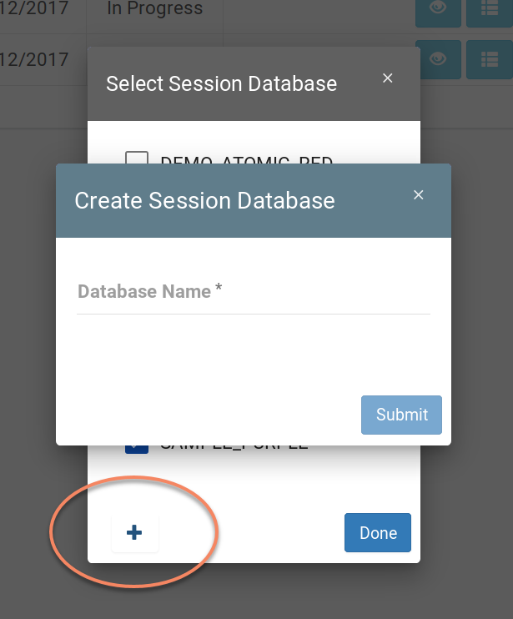

# Renaming downloadable reports

What is it?

Allows user to specify a name for the downloaded report

How does it work?

Click the download button on an Assessment:

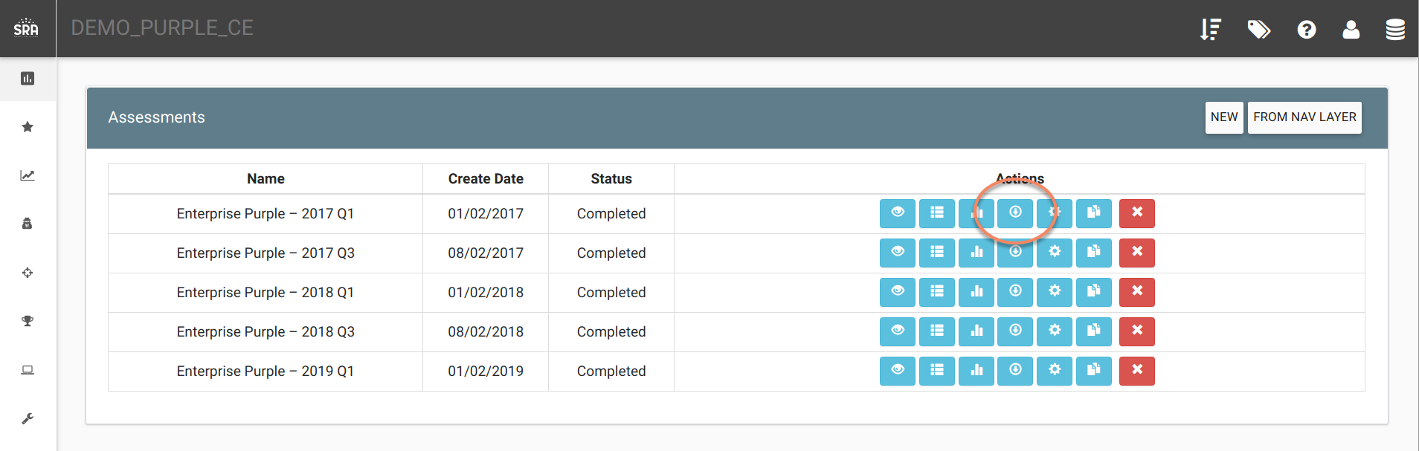

The next screen will let you enter in a report name:

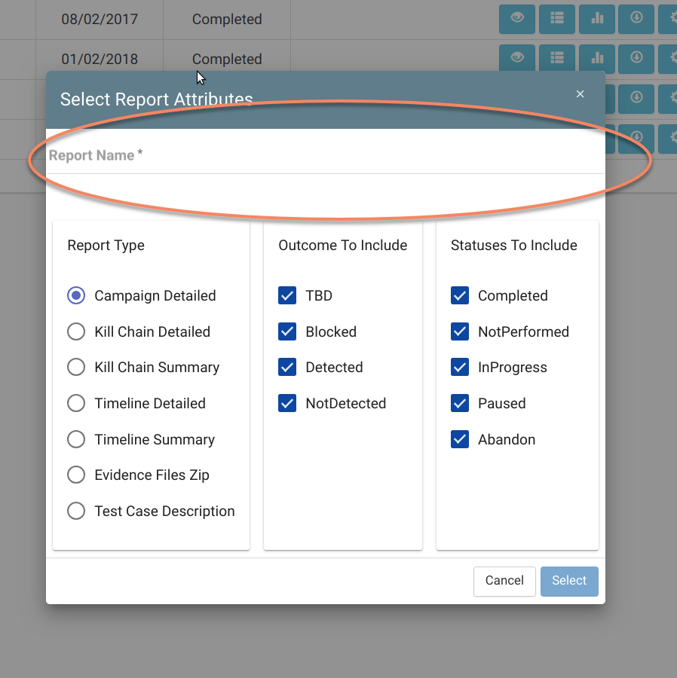

# Tagging column to downloadable reports

What is it?

Added Test Case tags as a column in the downloadable reports.

How does it work?

Automatically done when a report is downloaded.

# Help Button Improvements

What is it?

Provides a better user experience by providing useful links and tutorials, along with current software version and automatic checking for available software updates.

How does it work?

Navigate to the Help Section:

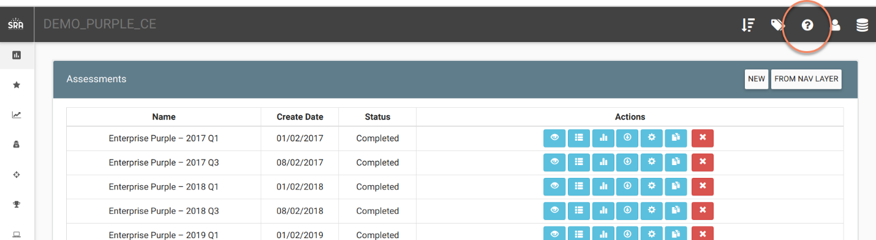

This will bring up the VECTR Help page:

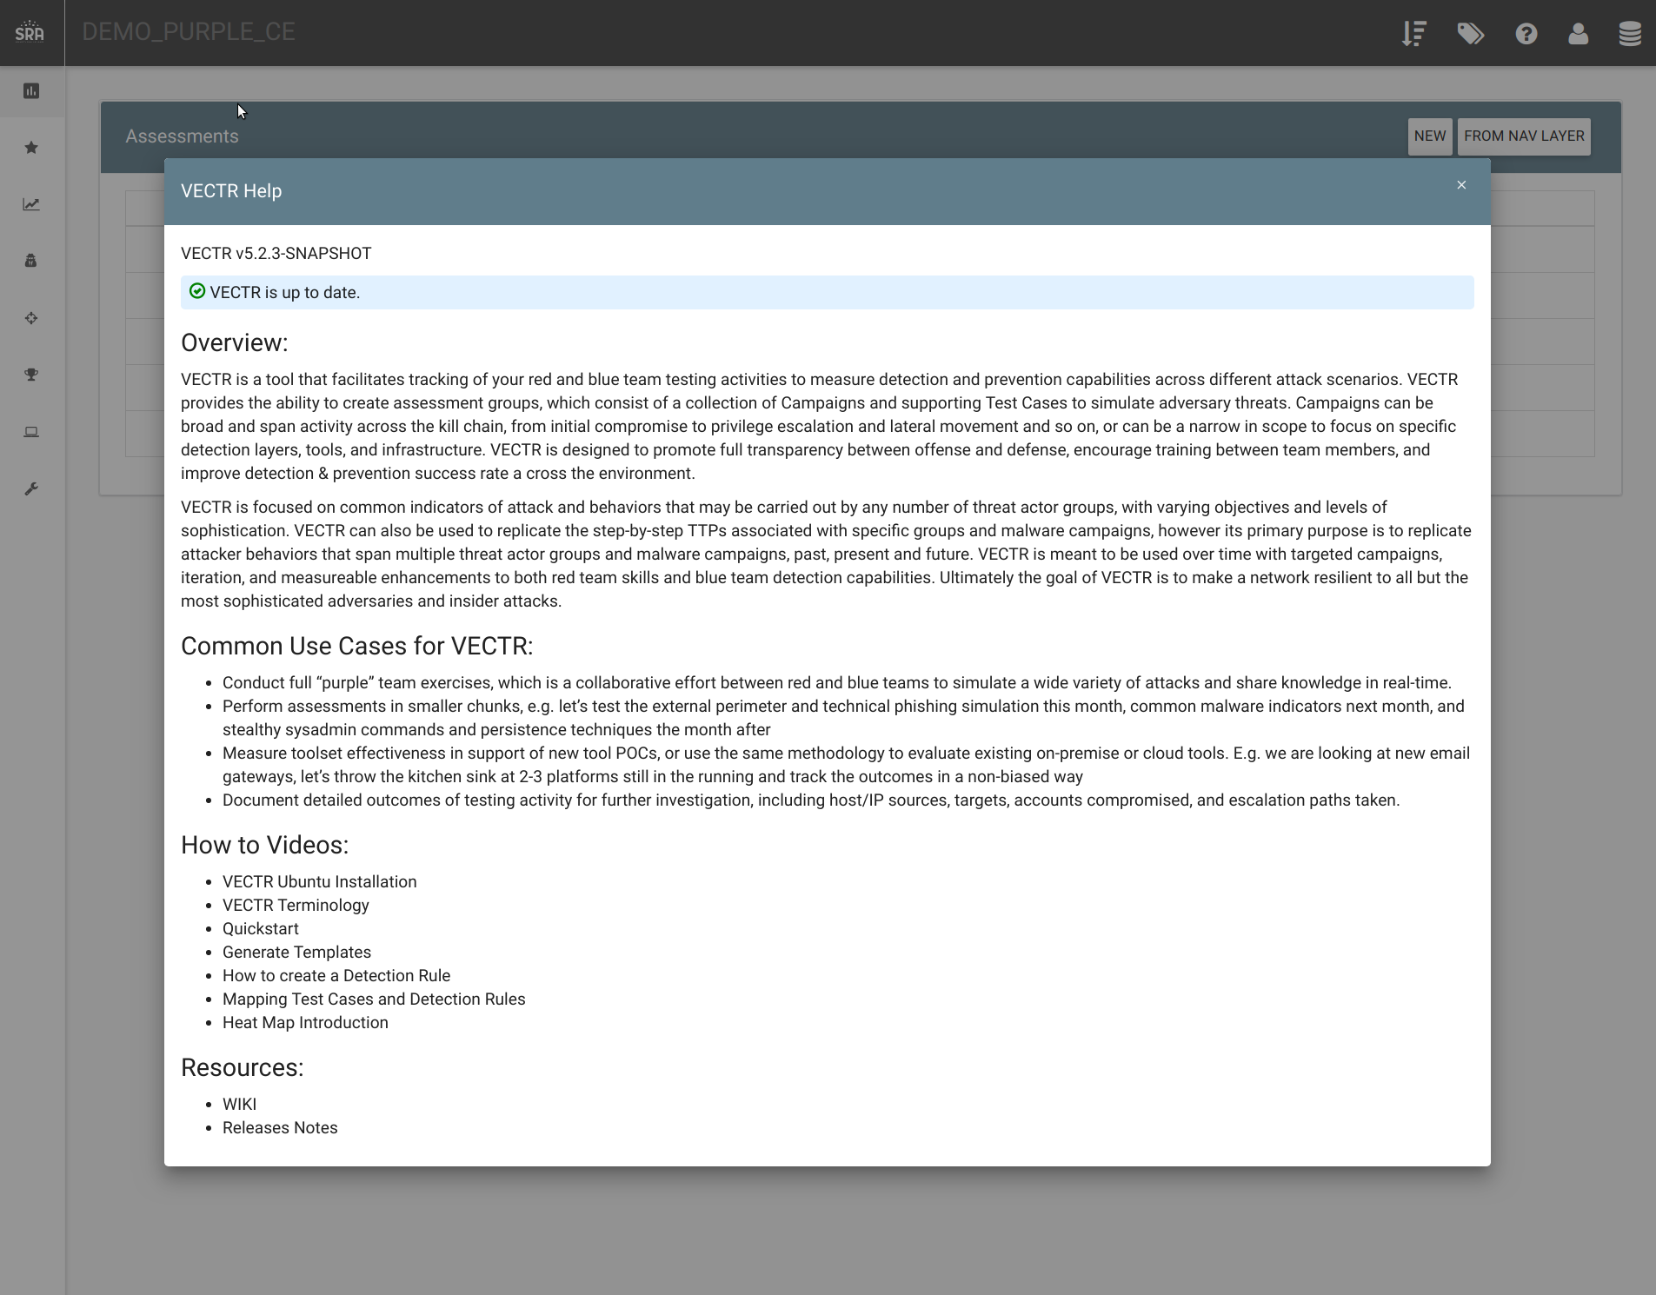

# Database CSV Dump

What is it?

Allows for a comprehensive csv dump of all Assessments, Campaigns, and Test Cases within a database. This dump is to be used outside of VECTR for further analysis. There is no import mechanism yet to bring the data back into the system via csv format.

How does it work?

Navigate to the DB Selection Icon:



There is a CSV Dump button in the dropdown:

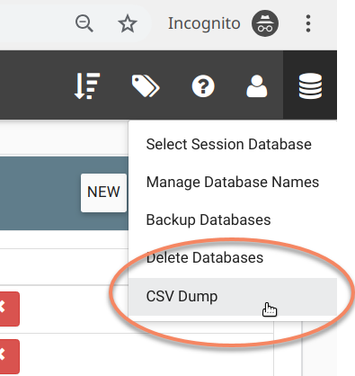

It will prompt you for the name you want to give the file:

